There are 3 important factors in anything-

1. People
2. Process
3. Technology

DevOps is an effective way to use people, process and technology.



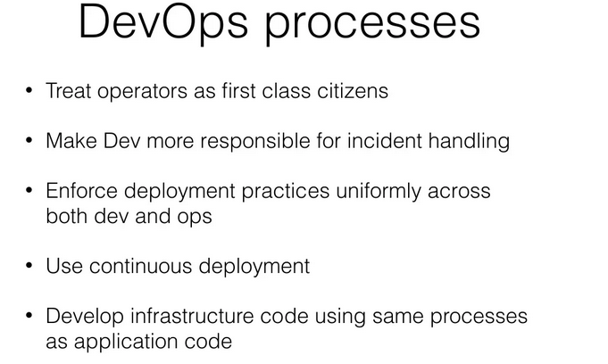

Effective way of utilizing people > Security guard to Police.

Effective way of using process > make process easy, fast and comfortable.

Effective way of using technology > Map reduce to find best route.